Department of Computer Science

NOVA School of Sciences and Technology



Phase 2

Bruna Arroja nº 56751

Pedro Nunes nº 57854

Daniel Cavalheiro nº57869

António Brejo nº58152

New functionalities:

* ISBN scan: After creating a new library a new way to add a entry becomes available. 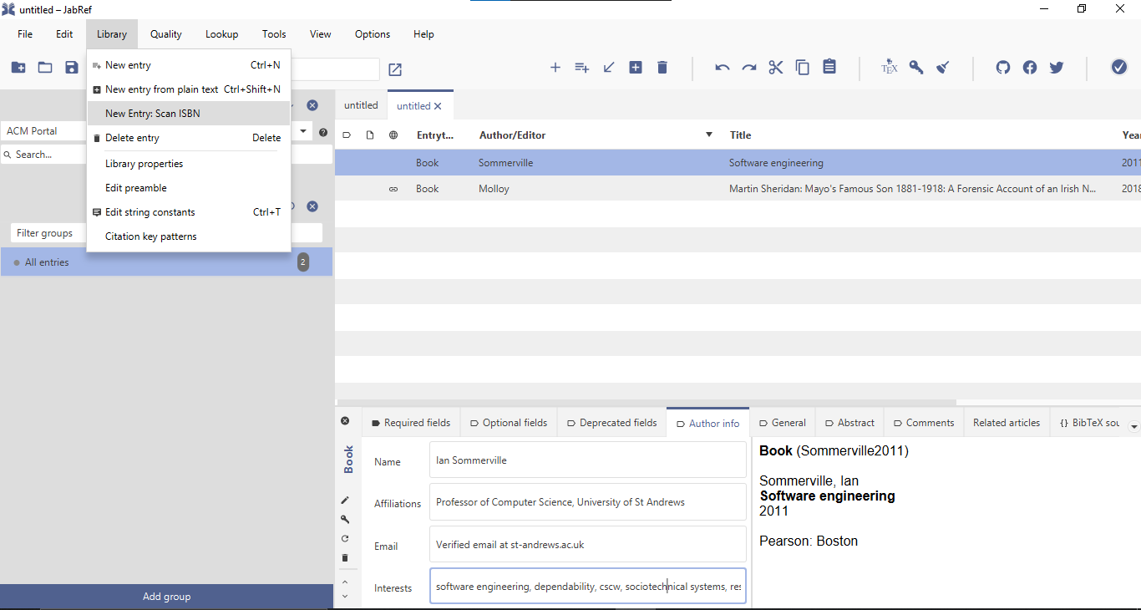New Entry Scan ISBN will allow the user to open their webcam and then hold up an ISBN barcode to it which in turn will be scanned and through Jabref and become a new entry. For this we used two distinct libraries, one was the webcam-capture, which we use to manipulate and use the webcam, if there is one, this library can be found on <https://github.com/sarxos/webcam-capture> . The other one is the zxing library which we use to decode the barcodes, this can be found on <https://github.com/zxing/zxing> . In some rare cases when a new entry is added with this new functionality exception will occur although the entry is still added successfully
* Additional author information: Double click on an entry to view more information about that entry, then click on the Author info tab to see more details such as affiliation, email, and the author’s interests. This data is taken from Google Scholar therefore it is only possible to get data on entries present in that database. We use SerpAPI to scrape results from the Google Scholar Profiles search page. <https://serpapi.com/google-scholar-profiles-api>

Link - <https://youtu.be/uMkOBIs-hUs>

Note: For reasons unknown to us when a group member added a new jar library to the lib folder in jabref and added it as a dependency another group member after a pull would have to add the dependency again. So, the teachers may have to do the same.

In *File->Project Structure->Project Settings->Modules* and then on the right-hand side select *Dependencies* then press the *+* icon, select *Jars or Directories* and find the lib folder in the Jabref project and finally select to add the following jar files:

* core-3.4.1.jar
* javase-3.4.1.jar
* main.jar
* webcam-capture-0.3.12-dist.jar